

CC LAB AWS 5

CLOUD FRONT

• Name :HITU RAJ

• Roll no. :2005025

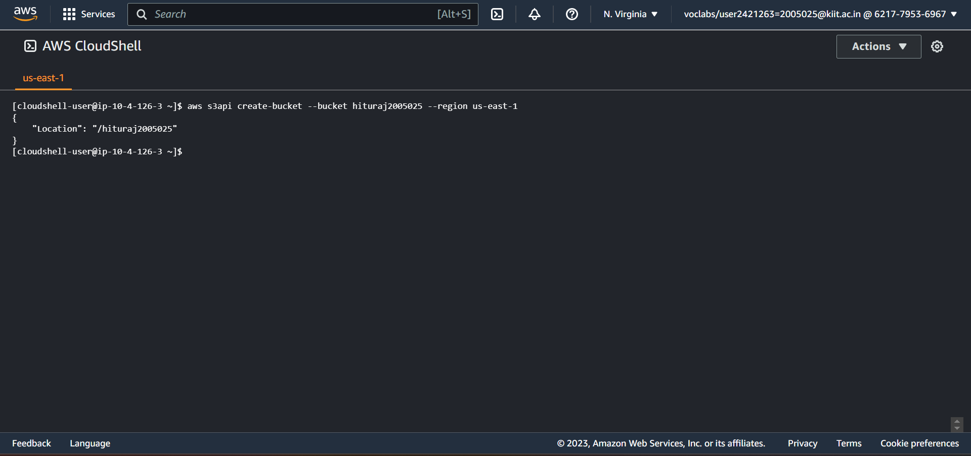• Branch :CSE-10

**Task 1. Create an S3 bucket using the AWS CLI**

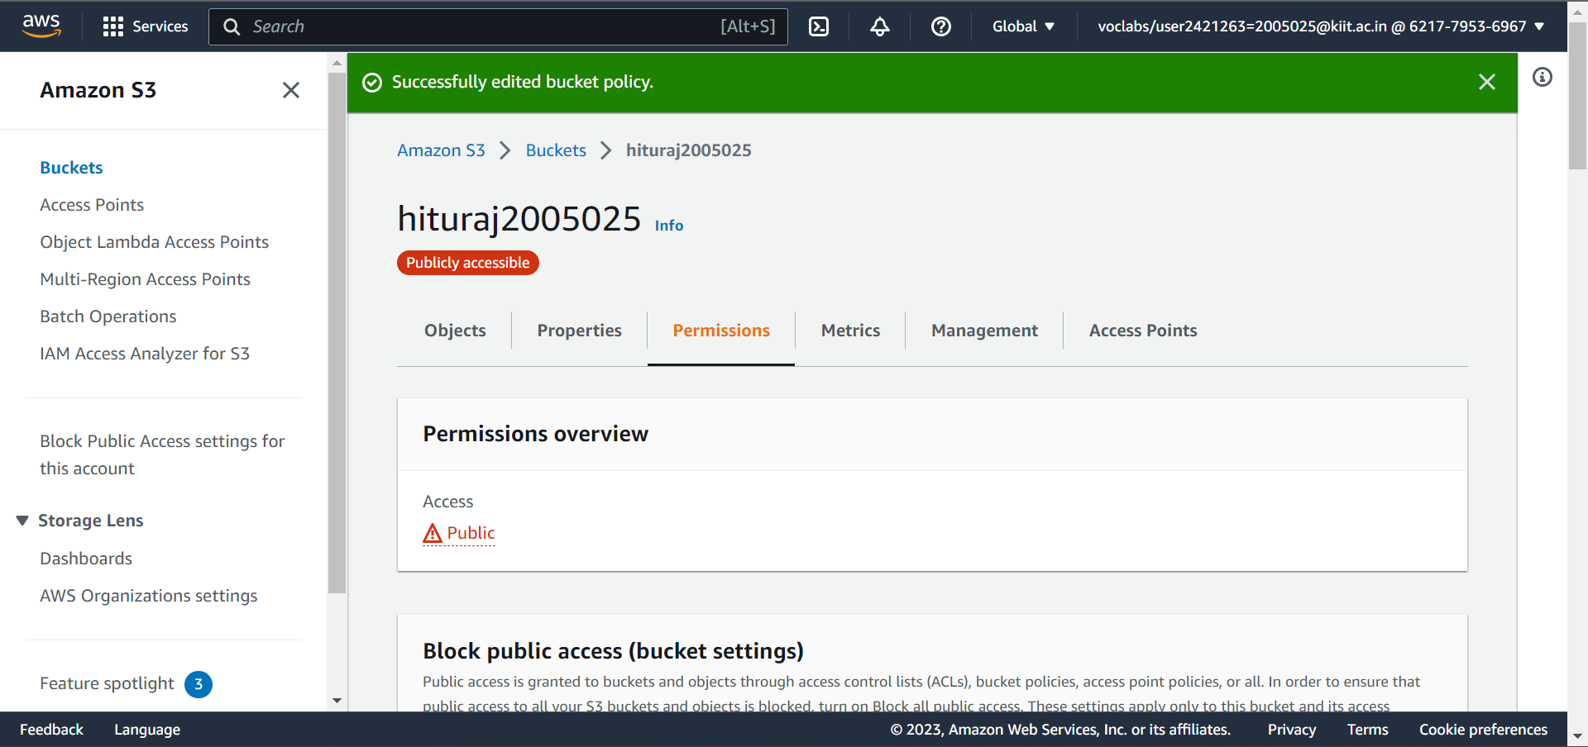**Task 2. Add a bucket policy**

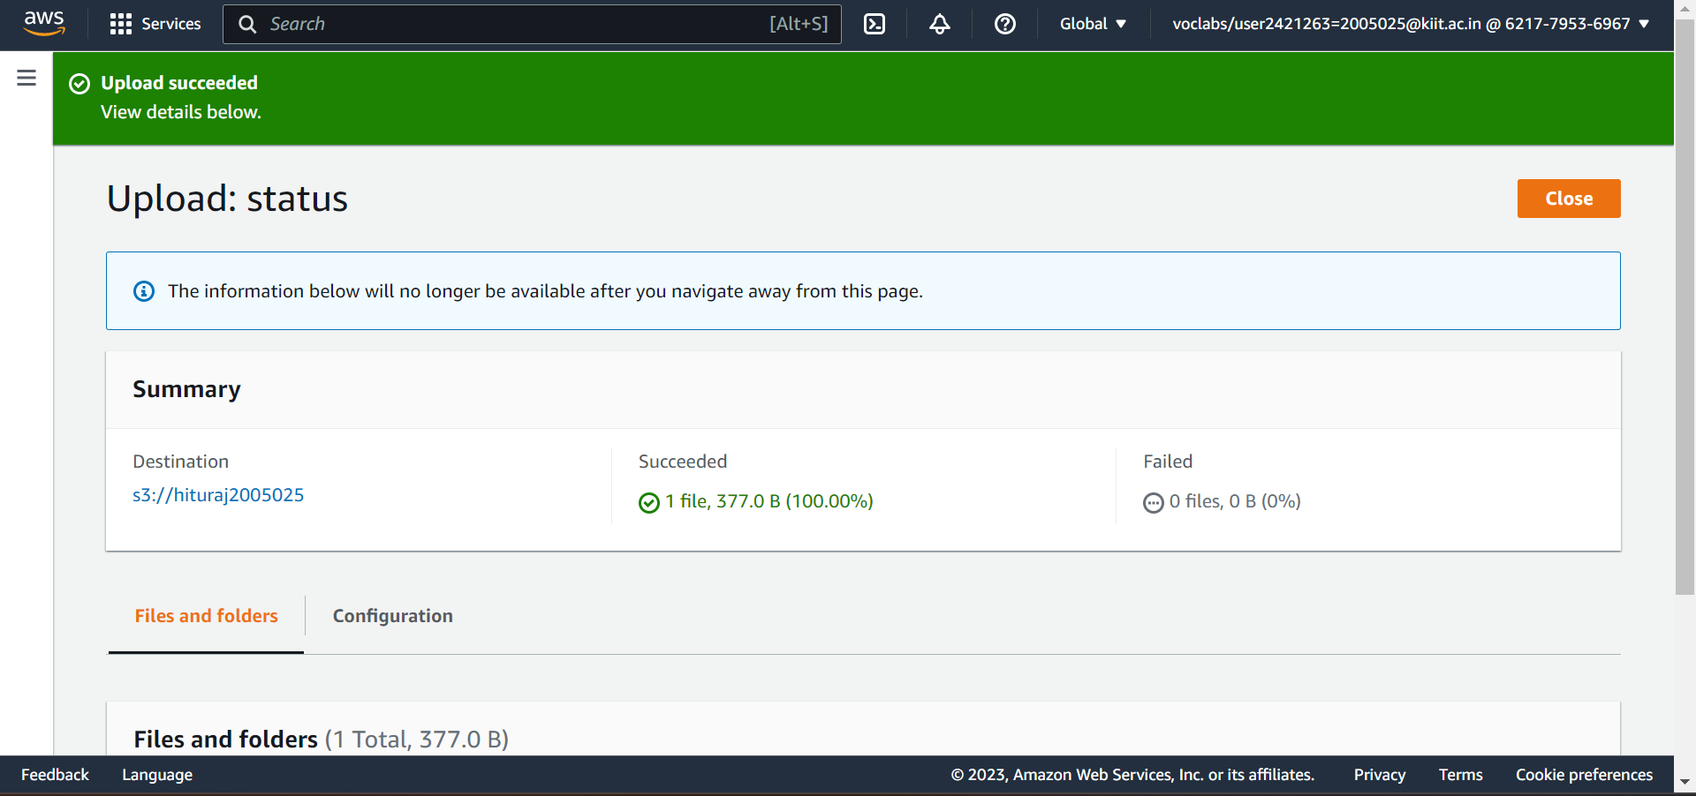**Task 3. Upload an HTML document**

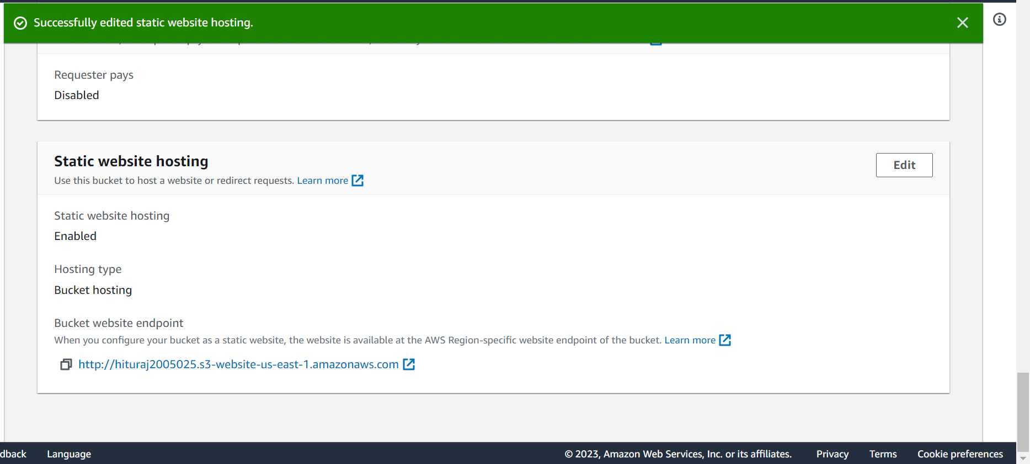**Task 4. Test your website**

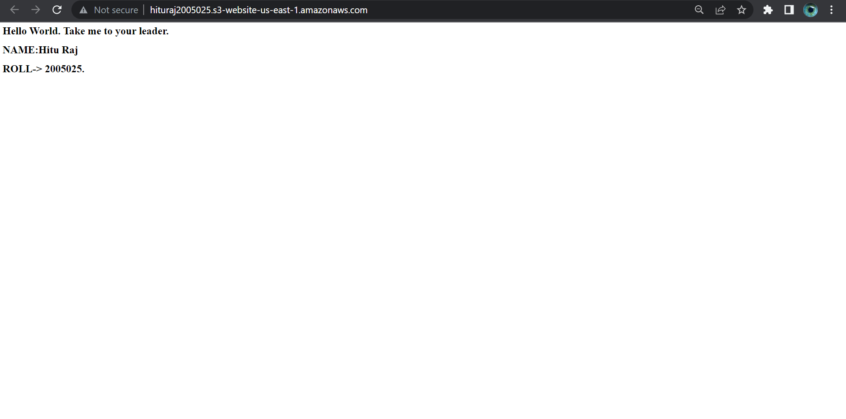

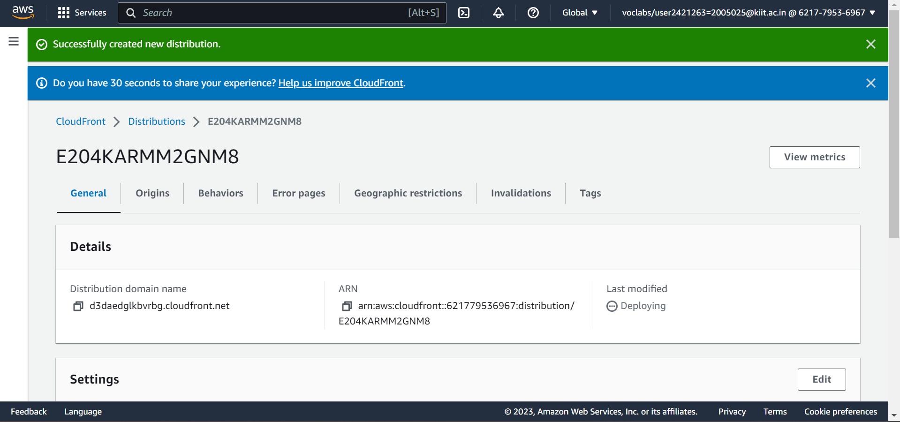**Task 5. Create a CloudFront distribution to serve your website**

Domain name: <https://d3daedglkbvrbg.cloudfront.net>

Uploading image in clound front

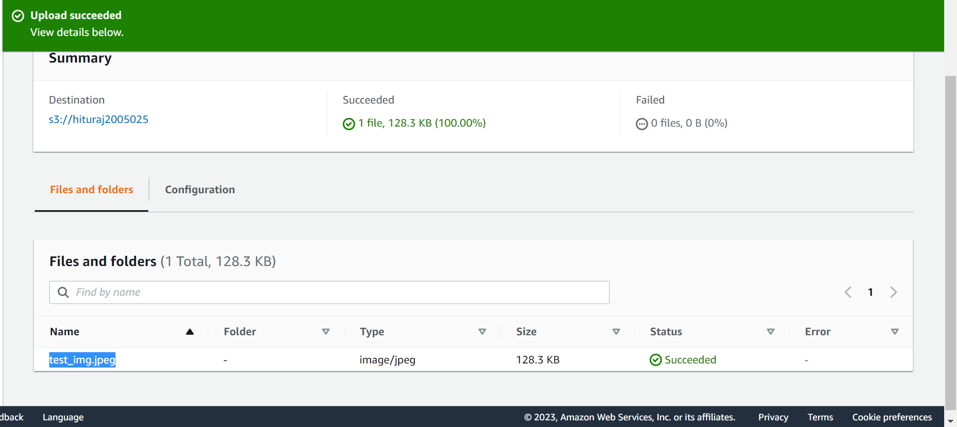

ACCESSING IT USING THE HTML FILE

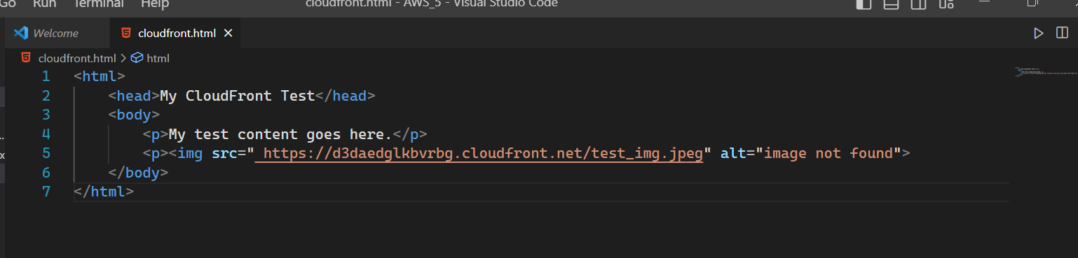

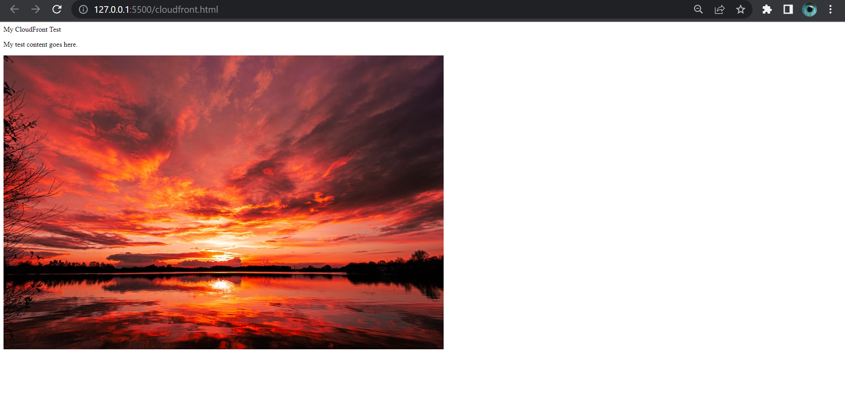OUTPUT

SUBMITTED BY:

HITU RAJ

2005025

CSE 10